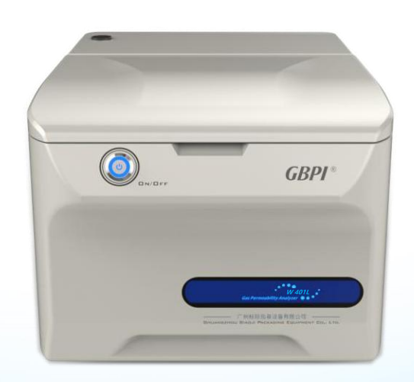
Introduction
Infrared Method
Water Vapor Permeability Analyzer
W401L

Infrared method water vapor transmission rate tester W401L is a high-end precision packaging material testing instrument, newly developed and upgraded by GBPI Research and Development Team based on ASTM, GB standard requirements and market demand. It is used to test the water vapor transmission rate of samples under set temperature and humidity conditions. It is suitable for the water vapor transmission rate performance test of films, sheets, papers, packages and various materials in the fields of food, medicine, medical equipment, daily chemistry, photovoltaic electronics, etc.

Test principle
W401L water vapor transmission rate tester adopts the principle of infrared method. Fix the pre-treated sample in the middle of the test chamber, divide the test chamber into a high-humidity side and a low-humidity side, the humidified nitrogen flows on one side of the film, and the dry nitrogen (carrier gas) flows at a fixed flow rate on the other side, in the presence of a humidity gradient, water vapor will permeate from the high-humidity side to the low-humidity side, and the water vapor that passes through the sample is carried to the infrared sensor by the flowing dry nitrogen, and the water vapor transmission rate (and other parameters) of the sample is obtained by the electrical signal output by the sensor.
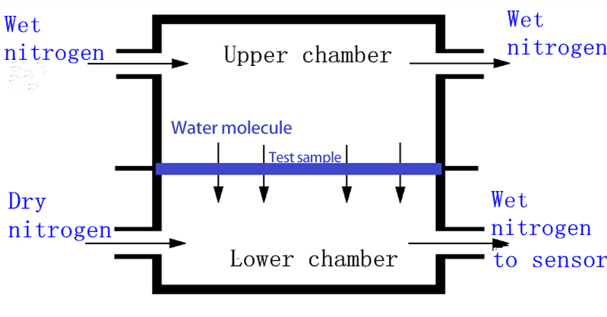
Working principle diagram

Standard
ASTM F 1249, BS EN ISO 15106-2, JIS K7129, GB/T 26253, YBB 00092003

Specification
Item | Technical Parameters
Test range | 0.01～200 g/(m²·24h)
Resolution | 0.0001 g/(m²·24h)
Temperature control range | 15～45℃
Temperature control accuracy | ±0.2℃
Humidity control range | (5～90) %RH, 100%RH
Humidity control accuracy | ±2%RH
Permeable area | 50.24 cm²
Sample size | Φ100 mm
Sample thickness | ≤3 mm
Sample quantity | 1 piece
Carrier gas | 99.999% Nitrogen (user-provided)
Carrier gas pressure | ≥0.1 MPa
Carrier gas flow | 5~100 mL/min
Dimension | 380*545*315mm
Power | 450 W
Power supply | AC 220 V, 50 Hz

Features
- High-precision patented infrared moisture sensor
The high-precision infrared moisture analysis sensor independently developed and prepared by GBPI has ultra-high stability, ultra-low failure rate and ultra-long service life, high sensitivity, and a resolution of up to 0.0001 g/(m2·24h).
- Accurate and reliable test data
Precise control of test temperature and humidity. Equipped with a high-precision temperature and humidity sensor, the temperature and humidity of the test chamber are stable, the temperature control accuracy can reach 0.2°C, and the humidity can be accurate to ±2%RH.
Automatic test mode, real-time monitoring of temperature, humidity, flow values ​​and curves during the test process, high test repeatability.
- Ultra-wide test range, high instrument applicability
The instrument is equipped with a single cavity, which is compact and flexible, saving space.
Ultra-wide test range [0.01～200 g/(m2·24h)], meeting the test requirements of various high, medium and low barrier materials, with the addition of adapter accessories, it can test the water vapor permeability of bottles, bags, bowls and other containers excess.
- Intelligent operating system, global certification
Self-developed intelligent operating system, modular design, flexible setting of test parameters, intuitive and convenient operation, while meeting the needs of scientific research and testing.
Designed according to the GMP appendix "Computerized System", it has an audit trail function and multi-level authority settings for users, which can meet the needs of the pharmaceutical industry for data traceability.
Personalized test reports can be set on demand, data output forms in multiple formats are supported, electronic signatures, and online submission of audit reports are supported.
- Professional calibration service, accurate and reliable data
Our company has the Water Vapor Transmission Rate "National Standard Substance Grading Certificate" approved and issued by the "General Administration of Quality Supervision, Inspection and Quarantine of the People's Republic of China", the standard substance number (GBW(E)130543 / GBW(E)130544). The self-developed national standard material is used to calibrate and verify the instrument to ensure the accuracy, versatility and authority of the test data.

Application
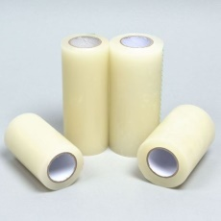 | Film | Water vapor transmittance test of various plastic films (PP/PET/PE/PVC/BOPP/CPP, etc.), plastic composite films, paper-plastic composite films, metal composite films, co-extrusion films, aluminized films, degradable packaging films (PLA/PBAT/PBS, etc.) and other film-like materials.
 | Sheet | Water vapor transmittance test of solid pharmaceutical hard sheets (PP/PVC/PTP, etc.), metal composite sheets, rubber sheets and other flakes.
 | Paper, cardboard and its composites | Water vapor transmittance test of coated paper, silicone paper, cigarette bag aluminized paper, paper aluminum-plastic composite sheet and other paper and cardboard.
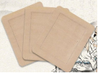 | Medicinal patches | Water vapor transmission performance test of medical plasters
 | Package | Customizable fixtures can be extended to packages such as pharmaceutical polyethylene bottles, sealed bags, pharmaceutical ointment tubes, infusion hoses, plastic trays, etc.

Factory configuration
Standard configuration | Power cord, communication line, sample cutter, sealing grease, ferrule joint, reference material, hexagonal wrench, syringe, sealing ring, syringe sealing ring, fork wrench, Phillips screwdriver, mouse, metal gas tube
Optional | Computer, Metrology certificate, Air compressor
Remark | 1. Standard laboratory environment;  2. Power requirements: 220V regulated power supply, one three-hole three-position switch socket;  3. Computer requirements: standard configuration (Windows10, with a nine-pin serial port);  4. Other accessories: a bottle of 40 liters of nitrogen gas (purity above 99.999%) is used for calibration, and other gases are customized;  5. Drying dish (all samples need to be dehydrated and degassed for 24 hours);  6. Distilled or purified water;  7. Air compressor.

Note: GBPI has always been committed to the innovation and improvement of product performance and function. For this reason, product technical specifications and appearance will also be changed accordingly. The above situation will not be notified. GBPI reserves the right of modification and final interpretation.

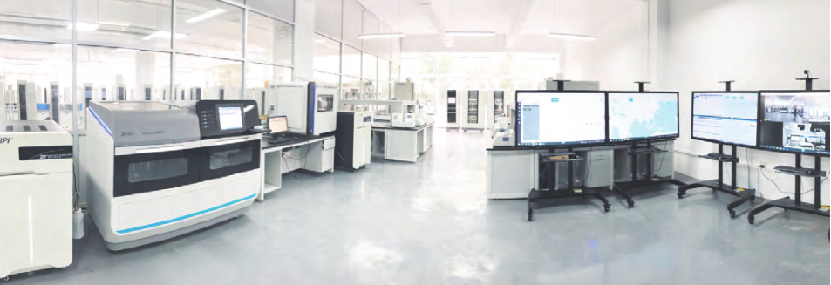
Service Commitment
- Free packaging inspection technical support.
- One-year warranty for instrument, free software upgrade service, and lifetime free technical support.
- Free to the factory to train the operation of the instrument, qualified people issued graduation certificates, free accommodation and food.
- Instrument “trade-in” policy and provision of backup instruments in case of failure.
- There is a testing center (CNAS L8185) to provide incoming sample testing and sample data comparison services.
- Set up a Reference Standards Development Center to provide calibration services.

Company Introduction

Guangzhou Biaoji Packaging Equipment Co., Ltd. was established in 2002 and located in Guangzhou Economic Development Zone. It is a company integrating R&D, production and sales of packaging testing instruments, packaging equipment, modified atmosphere preservation equipment and other products, as well as providing third-party testing and standard material proficiency testing. It is committed to providing comprehensive, professional and high-quality products and technical services for packaging, food, medicine, testing and other industries.

Write industry standards with quality, and become the leader and leader in the field of global packaging testing. The 80,000-mile journey is sailing, and GBPI will escort you!

Address: No. 1, Minghua 3rd Street, Jinxiu Road,
Guangzhou Economic and Technological Development Zone
Tel: 020-8615 3789, 8615 3790
After-sales hotline: 4007886855
Website:https://www.gbpitester.com/
Email: info@gbtest.cn
WeChat QR code

Website QR code

