GH-D Digital Thickness Meter
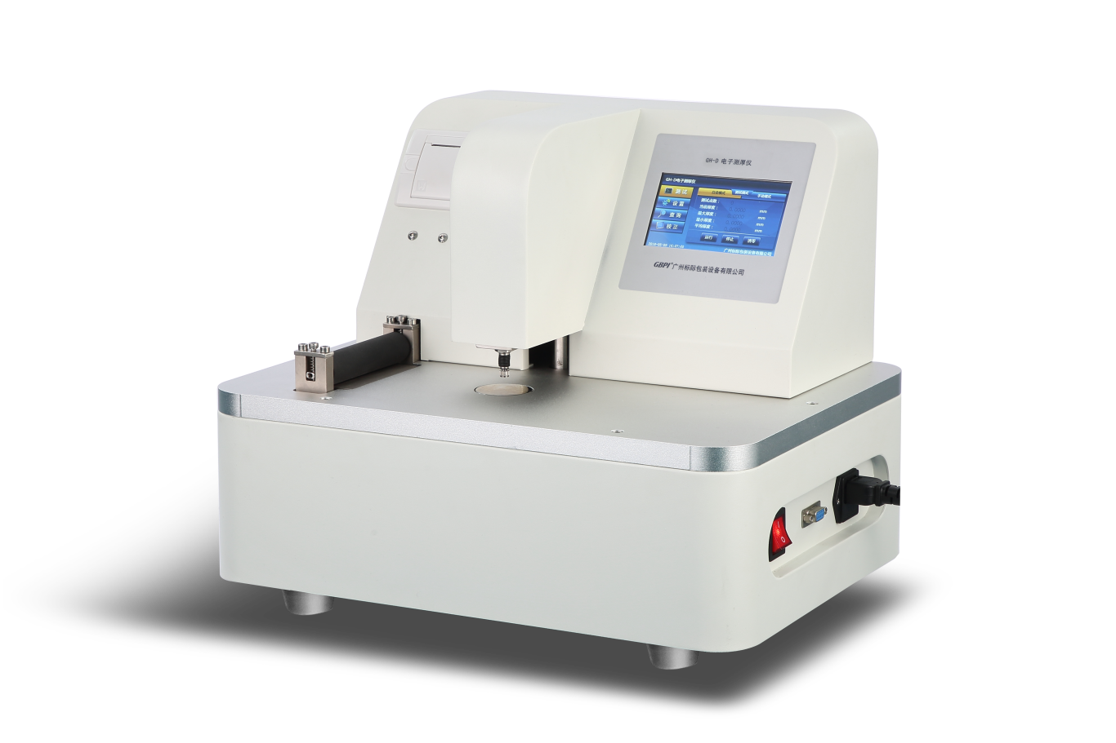
Application
This instrument is a high precise thickness meter integrating optics, machinery, electronics and algorithm. Easy to operate. Test results are displayed digitally. And can connect to computer for automatic control. Mainly used for measuring or comparing the thickness of plastic film, paper and other materials.

Standards
GB/T 6672、GB/T 451.3、GB/T 6547、ISO 4593、ISO 534、ISO 3034、ASTM D645、ASTM D374、ASTM D1777、ASTM F2251、TAPPI T411、DIN 53105、DIN 53353、JIS K6250、JIS K6328、JIS K6783、JIS Z1702、BS 3983、BS 4817

Features
- High precision (0.1μm), digital display, stable, easy to operate.
- Measuring mode: manual and automatic.
- Single point and multiple points measurement.
- LCD display, real time display of max, min, average and current values.
- With built-in printer, can print test report.

Specifications
Item | Technical Parameters
Test range | 0~3mm
Test resolution | 0.1μm
Number of test points | 0~30 Points
Space of sampling | 0~1000mm
Measure force | 0.5N
Measure head size | Φ5mm (can customize)
Working Temperature | 0~40℃
Power | 1000W
Power supply | AC 220V，50Hz
Instrument size | 400×310×340mm
Weight | 25kg

Note: GBPI is always committed to product innovation and improved performance, so accordingly product technical specifications are subject to change without notice. GBPI reserves the right to amend and the final power of interpretation.

