Gas Permeability Analyzer N530 2.0
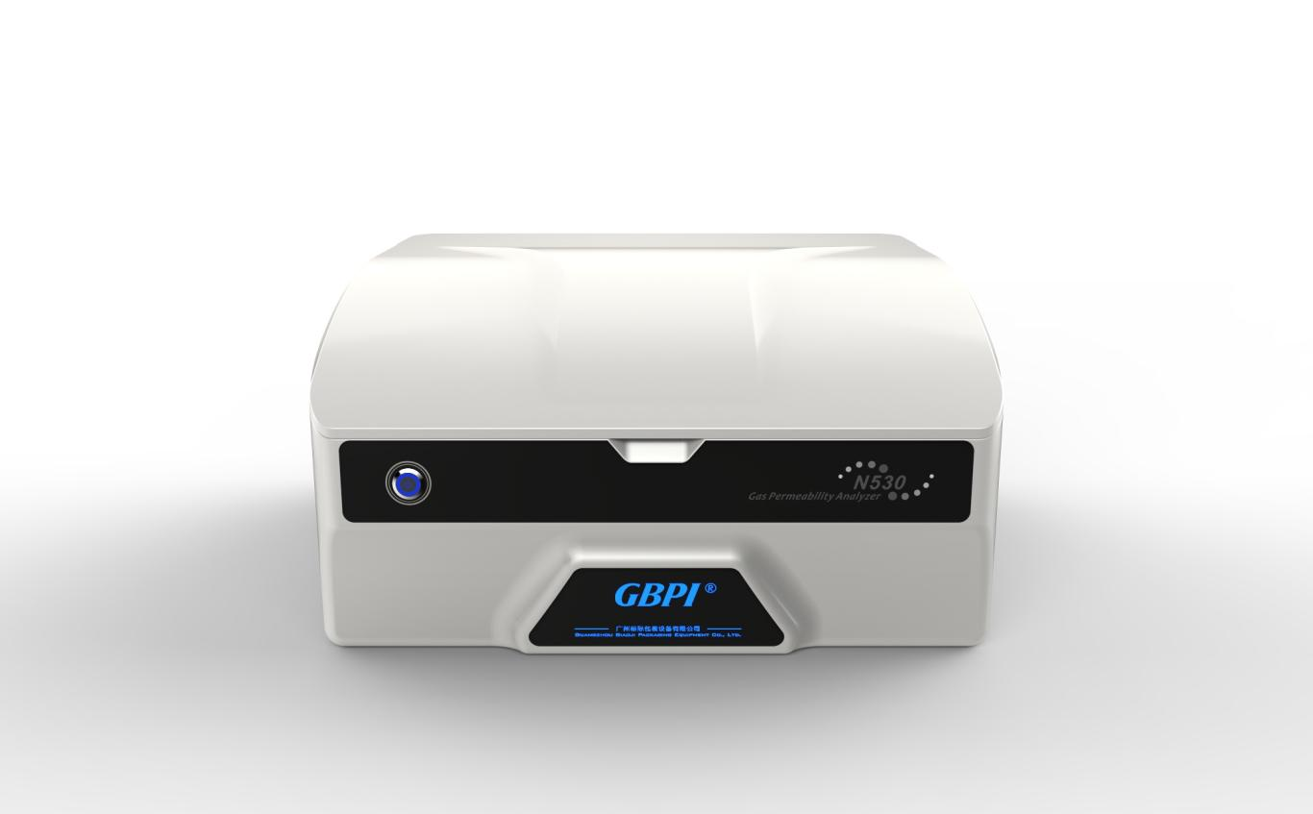
Introduction
Based on the test principle of the differential pressure method, N530 is designed with reference to the GB/T 1038 standard and used to test the gas transmission rate (quantity) of film or sheet materials.
Applied to;
1) Plastic film, composite film, aluminum foil, aluminized film, etc.;
2) Various sheets, plates, rubber, ceramics, etc.;
3) Packaging containers, such as bottles, bags, bowls, etc.;
4) Others applications, such as solar backplanes, liquid crystal display films, medical patches, etc.
Used in quality inspection, drug inspection, scientific research, packaging, film, food, medicine, daily chemical products, electronic and other industries.

Features
- Accurate and reliable data
- Our company has approved and issued by the "General Administration of Quality Supervision, Inspection and Quarantine of the People's Republic of China". Gas Permeability Tester "National Standard Material Classification Certificate" and "National Standard Material" Manufacturing Measuring Instruments License (GBW(E)130541/ 2). Use national standard materials to calibrate and verify the instrument to ensure the accuracy, versatility and authority of the test data.
- Easy to operate
- Professional software with simple interface, easy to use and flexibly to set test process.
- Fully automatic operation, judge and stop automatically.
- Five sets of curves of temperature, upper cavity pressure, lower cavity pressure, pressure difference change, and penetration are displayed in real time. The curves with conceal function, support query function for background data.
- Professional test report, automatically generate and can be exported in PDF format.
- Advanced technology
- Automatic pressure maintaining technology, which automatically maintains the pressure difference on both sides of the sample (the pressure difference can be adjusted arbitrarily).
- Temperature control: water-cooled temperature control technology, automatic heating and cooling. No needing external temperature control device to avoid the disadvantages of large size and multiple failures. High measurement accuracy, accurate to 0.1℃.
- High test efficiency
- Three chambers are independent. Each chamber can be tested independently, can test three same or different samples, and issue three independent test reports to improve the effective test efficiency.
- Adapt to film testing with different barrier properties.
- Measurement precision up to 0.01 cm³/（m²·24h·0.1MPa）, can test high barrier materials, such as aluminum foil.
- By adding package-testing accessories, can test the gas permeability of bottles, bags, bowls and other containers.
- Authority management and data tracking
- The software is designed according to the requirements of the computerized system in the new GMP appendix.
- Needing user name and password to log in.
- Users are divided into multiple levels of system administrators, instrument administrators, auditors, and operators.
- The system administrator can adjust the authority of various levels; like increase and decrease the system control items of a certain level.
- With audit trail function (test trail, log trail). Every data change is recorded to ensure the safety and integrity.
- Stable, reliable and easy to maintain
- Professional pressure sensor with high precision and good stability can run for a long time.
- The sensor has an automatic protection function that exceeds the range to avoid damage to important sensors when the instrument fails.
- Functional modular design for easy to maintain.

Standard
GB/T 1038-2000, ISO 2556-1974, ISO 15105-1-2007, ASTM D1434, JIS K7126-1-2006, YBB00082003-2015

Technical Specification
Items | Technical Parameters
Testing range | 0.02～50000 cm3/（m2·24h·0.1MPa）
Testing accuracy | 0.001 cm3/（m2·24h·0.1MPa）
Testing temperature range | 15～60℃
Temperature precision | ±0.1℃
Vacuum degree | ＜20Pa
Vacuum resolution | 0.01Pa
Test pressure | 0.1MPa
Test gas | O2, CO2, N2 etc.
Test area | 50.24 cm²
Sample size | Φ110 mm
Sample thickness | ≤2mm
Number of samples | 3 pcs
Power | 750W
Power supply | AC 220V, 50Hz

Guangzhou Biaoji Packaging Equipment Co.，Ltd. is a high-tech service enterprise with independent intellectual property rights. The company specializes in the R&D, production, sales and service of packaging testing instruments and software, and has provided the most competitive laboratory construction program for more than 10,000 enterprises and institutions in more than 40 countries and regions around the world. The service covers the fields of national quality inspection and drug inspection institutions, scientific research institutions, packaging, printing, food, medicine, daily chemical products, chemicals, new energy, new materials and so on.

Service & Support
- Provide free packaging inspection technical support.
- One-year instrument warranty, free software upgrade service, free lifetime technical support.
- Free to come to the factory to train equipment operation, qualified candidates will be awarded a diploma, and free board and lodging will be provided.
- The policy of “replace the old for the new” instrument, and provide a backup instrument for use in case of failure.
- Set up a testing center (CNAS L8185) to provide customers with sample testing and sample data comparison services.
- Set up a standard material development center to provide customers with instrument calibration services.
- Service hotline: 4007886855/QQ: 3413560795.

Following the company's WeChat public account; gbtest
Getting the latest product information.
Guangzhou Biaoji Packaging Equipment Co.,Ltd.(GBPI)
Address：NO.1 Minghua 3 Street, Jinxiu Road, Economic Development Zone, Guangzhou, China
Phone：020 -82222550, 87592871
After-sales hotline：400-788-6855
Fax：020–82087405 Website：www.gbtest.cn

