GBB-F1 Heat Seal Tester
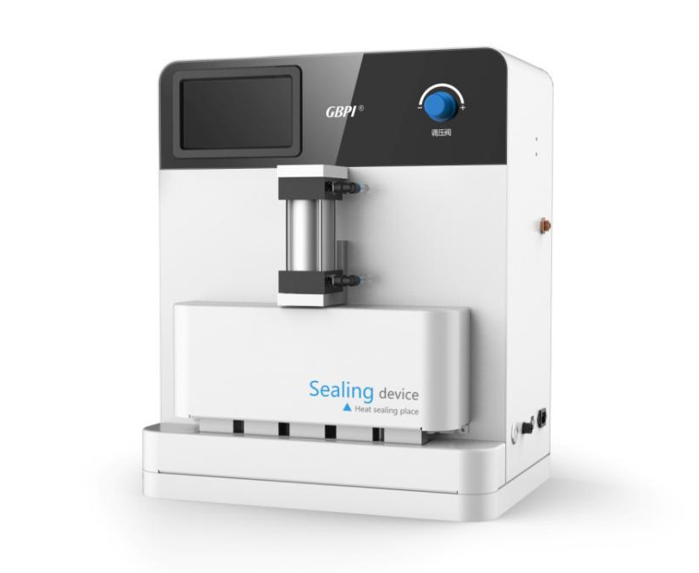
Application
GBB-F1 Heat Seal Tester is to test the temperature, pressure, and time for heat sealing of various film materials. It is applied to quality inspection organizations, drug control institutions, research institutes, packaging, thin film, food companies, pharmaceutical enterprises, personal care industry and so on.

Standards
QB/T 2358, ASTM F 2029, YBB00122003

Features
- Five point heat seal, can set six different temperature at the same time (low bar and five upper bars).
- Upper and lower heat seal bars have independent temperature control and setting.
- The equipment adopts digital P.I.D. temperature to control, the temperature is more accurate. Temperature sensor is easy to calibrate.
- Using compressed air, pneumatic drive. pressure test, convenient to set pressure according to sample from customer.
- Automatic and manual modes; use foot switch for manual mode.
- Support upgrade heat seal bar with anti-sticking function. Support customize size, shape and smoothness of heat seal bar.
- Touch screen shows the current temperature, heat sealing temperature, heat sealing pressure and heat sealing time of the upper and lower bar.

Specifications
Item | Technical parameters
Temperature range | Room temperature~250℃
Temperature precision | ± 0.1℃
Seal time range | 0.1s~99h 59min 59.9s
Pressure range | 0.1~0.8Mpa
Heat seal area | Upper bar 35×10 mm × 5 sections;  lower bar has silicone pad as buffer; ( Customize available )
Heat seal method | Two ways: automatic or manual, external air cylinder
Power supply | AC220V 50Hz
Instrument size | 500(L)×330(B)×570(H)mm

Configuration List
Spare parts
NO. | Name | Remark | Quantity
1 | Heat seal tester | GBB-F1 | 1 Set
2 | Power cable |  | 1 PC
3 | Gas pipe |  | 1 M
4 | Foot switch |  | 1 PC

Note: GBPI is always committed to product innovation and improved performance, so accordingly product technical specifications are subject to change without notice. GBPI reserves the right to amend and the final power of interpretation.

